Learning Journal Unit 4

Godfrey Ouma
University of the People
CS 1101: Programming Fundamentals
Janice Block
July 14, 2023

Part 1: Hypotenuse Function
Stage 1: Initial Function Definition and Test
Figure 1
Parts of a right-angled triangle
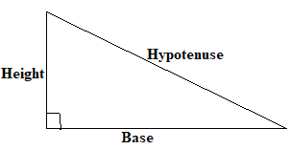
The development process begins with defining the function "hypotenuse(height, base)", which takes two arguments "height" and "base" of a right-angled triangle, as shown in Figure 1. A simple case is also included to make sure the function is computable. See the codes below.
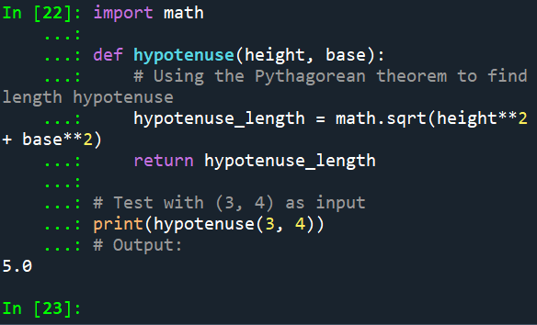
Stage 2: Performing Two More Test Cases
The function can undergo further validation by adding two more test cases with different arguments using other Pythagoras-associated triples, as shown below.
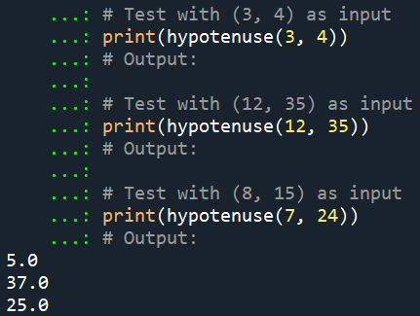
Explanation:
In the implementation above, the function "hypotenuse" takes two arguments: height and base, which represent two lengths of a right triangle shown in Figure 1. The function is set to apply the Pythagorean theorem ($hypotenuse={\left(\sqrt{{height}^{2}+{base}^{2}}\right)}^{2}$) to compute the length of the hypotenuse, which will be returned as the output. The first test case hypotenuse(3, 4) returns the length of length as 5.0 in the output, the second test case hypotenuse(12, 35) returns the length of length as 37.0 in the output, and the third test case hypotenuse(7, 24) returns the length of length as 25.0 in the output. All the test cases have successfully returned the length of the hypotenuse in the output to show that the function is working as anticipated. The three results prove that the function "hypotenuse(height, base)", can handle different input values and correctly compute the length of the hypotenuse for different right triangles. This supports Downey's (2015) claim that the purpose of incremental development is to add and test only a little amount of code at a time, hence avoiding lengthy debugging sessions.
Part 2: Custom Function
Part 2 entails creating a function called "calculate_profit" that calculates the selling price of an item given whose buying price and the percentage profit are indicated in the arguments. The development process of this code will be performed incrementally, and each stage recorded as shown below.
Stage 1: Initial Function Definition and Test
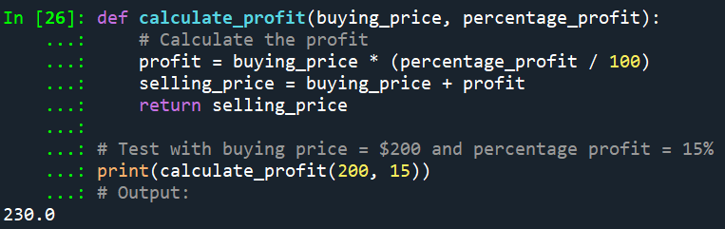
Stage 2: Performing Two More Test Cases
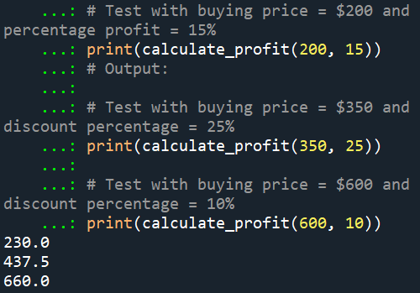
Explanation:
In the example above, the function "calculate_profit" takes two arguments: buying_price and percentage_profit. The function is then set to compute the selling price by finding the sum of profit and buying price. The profit is computed by taking the product of the buying price and the percentage profit divided by 100. The function then returns the selling price as the output. The first test case calculate_profit(200, 15) leads to the function correctly calculating the selling price as $230 when the original price is $200, while the percentage profit is 15%. The second and the third additional case tests, calculate_discount(350, 25) and calculate_discount(600, 10) return $437 and $660 respectively. Therefore, the three results confirm that the function “calculate_profit(buying_price, percentage_profit)” can handle different buying prices and percentage profits, correctly by computing the selling price accordingly. Similarly, just like in part 1, this supports Downey's (2015) claim that the purpose of incremental development is to add and test only a little amount of code at a time, hence avoiding lengthy debugging sessions.

Reference
Downey, A. (2015). Think Python: How to think like a computer scientist. Needham, Massachusetts: Green Tree

